**Fringe Fundraising Intern**

**Information Pack**

This pack contains the following information:

* Introduction
* Role Details
* Role Description
* Person Specification
* The Application Process
* Entitlement to work in the UK
* Overview of EFP
* Benefits

# **Introduction**

This is an exciting paid learning opportunity to make a real difference at the heart of Edinburgh’s largest foodbank charity. Our Fringe fundraising programme is growing, and we need someone keen to learn and bursting with ideas to join our team and make the 2025 Fringe a huge success.

The successful intern will be involved in organising collections, liaising with artists and venues, event planning and delivery (including working on our annual ‘Fringe Benefit’ comedy fundraiser), social media content creation, and generally making sure that everything goes without a hitch.

 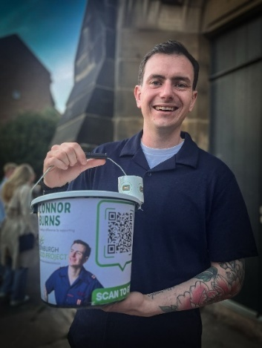 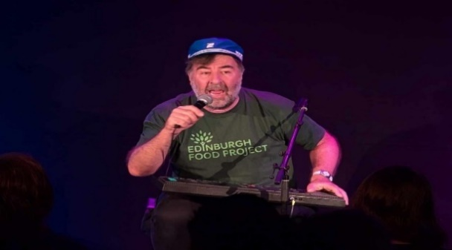

This year we are thrilled to have partnered with Assembly Festival on some exciting initiatives to take our fundraising to the next level. As well as working with the Assembly team to support fundraising through our ‘7-minute stage’ and collections around Assembly shows, the intern will have the opportunity to take on additional work with the Assembly team as part of their box office or front of house teams. There may also be the potential to undertake some shadowing in a department of interest to the intern, such as the management, operations, programming or marketing teams.

The intern will work closely with our Fundraiser and Communications Officer and will be supported to learn the fundamentals of fundraising. Edinburgh Food Project are proud members of Fundraising Everywhere who have agreed to provide the intern with access to a suite of online training and resources to support their learning.

In the months running up to the fringe we would like the intern to work during normal office hours – 5 hours a week in May, rising to 10 hours in June and July. We can be flexible with exact hours and location, but there will need to be some time spent each week at our base in Broomhouse. In August we are offering 20 hours a week, which will be largely during normal working hours, but which may involve some evening or weekend work.

Attitude and aptitude are far more important than experience. If you are interested in a career in fundraising or events, and are creative, outgoing, and enthusiastic, then this may well be the internship for you.

To apply please send us your CV and a short pitch telling us why you want to be this year’s Fringe Fundraising Intern and why you think you’re the right fit for the role.

The format of your application is completely up to you – we will welcome written submissions, videos, voice notes etc. Just please keep it short and simple (3 minutes/500 words) and let your true self shine through (see our [note about the use of AI](https://edinburghfoodproject.org/work-with-us/)).

If you have any questions at all about the internship, then please contact Fiona or Calypso at fundraising@edinburghfoodproject.org.

We look forward to reading your application.

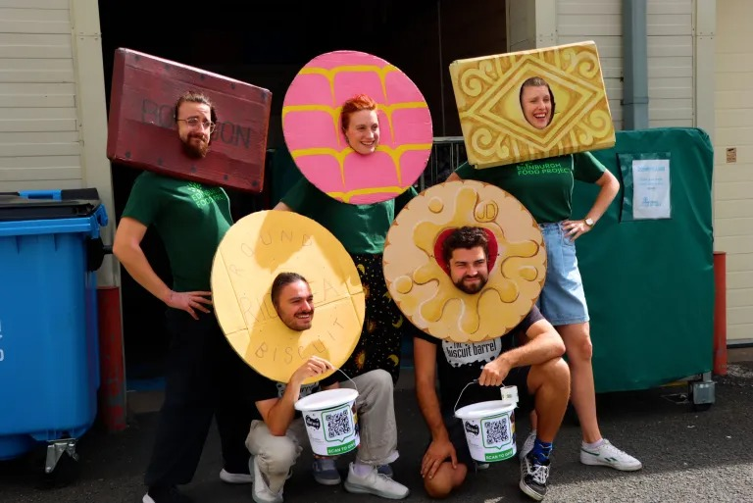 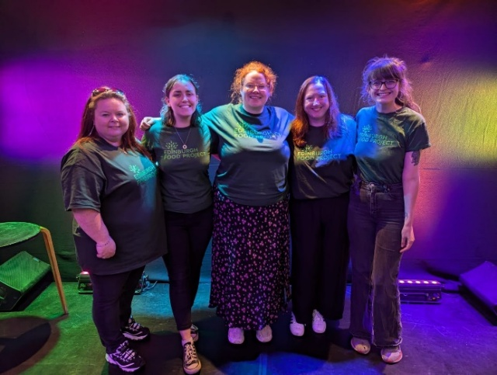

**Role Details**

**Job title:** Fringe Fundraising Intern

**Reporting to:** Fundraiser

**Direct Line Reports:** None

**Contract Type:** Fixed Term 16 weeks (mid-May to end August)

**Hours:** 185 hours total – approx. 5 hours per week during May, 10 hours per week in June and July, 20 hours per week in August

**Work Pattern:** Flexible to the needs of the role, including some evening and weekend work

**Salary:** £12.60 per hour

**Location:** New Lairdship Yards, Broomhouse Road, Edinburgh, EH11 3UY

**The Application Process**

**Application deadline:** 9am 21 April

**Interview date:** TBC but likely to be 1 or 2 May

**Interview location:** In person, Edinburgh

**Interview format:** 45-minute interview. Competency-based questions will be sent out to candidates in advance of the interview together with timings and information about the selection panel. There may also be one or two small tasks to complete in advance that will be relevant to the role.

**To Apply**: Please send your CV plus a statement outlining why you are interested in the internship, and why you think that you’re the right person for the role to [recruitment@edinburghfoodproject.org](mailto:recruitment@edinburghfoodproject.org)

This can be in any format that you like (written, audio, video) but please keep it to 500 words or 3 minutes.

**AI statement:**  <https://edinburghfoodproject.org/work-with-us/>

**Please also complete our** [Equality and Diversity monitoring form](https://forms.office.com/r/dmMWp0vFTa)

**Entitlement to work in the UK**

A job offer will be subject to confirmation that you are permitted to work in the UK in accordance with the provisions of the Asylum and Immigration Act 1996. You will be asked to provide evidence of your entitlement to work in the UK if you are successful and an offer of employment is made. Please note that Edinburgh Food Project does not hold a sponsor licence and, therefore, cannot issue certificates of sponsorship under the points-based system.

**Role Description**

**Purpose of Role:** To support Edinburgh Food Project’s fundraising efforts during the 2025 Edinburgh Festival Fringe.

**Essential Tasks**

* Liaising between Edinburgh Food Project and fringe venues and performers including Assembly
* Researching and approaching acts/venues to collaborate with
* Working with the Fundraiser on the ‘7-minute stage’
* Working with the Fundraiser on our ‘Fringe Benefit’ fundraiser
* Organising and conducting exit collections at participating shows
* Organising and supporting our Fringe Volunteers to conduct exit collections
* Coordinating the safe transfer of cash collected to the EFP office and counting it for banking
* Initiating further ideas to contribute to Fringe fundraising
* Contributing content to our social media channels
* Engaging in learning about Fundraising and Events
* Any other reasonable tasks as requested by the Fundraising Lead or Senior Management Team

**Person Specification**

**Essential Criteria**

1. Creative and enthusiastic with the ability to spot opportunities and take the initiative
2. Well-organised with the ability to juggle multiple priorities
3. Digitally savvy with the ability to master multiple online systems and platforms
4. Genuine interest in pursuing a career in fundraising or events
5. A commitment to the vision, mission, and values of Edinburgh Food Project

**Desirable Criteria**

1. Specific experience of conducting the tasks listed in the Role Description
2. Experience of events and/or fundraising

**About Edinburgh Food Project**

Edinburgh Food Project is within a period of rapid change as we work towards a future without the need for foodbanks.

**Vision**

An Edinburgh without poverty, where everyone has what they need to thrive.

**Mission**

To provide food and other everyday essentials, support, and advice, while working with individuals, communities, and partners to address the root causes of poverty.

**Values**

**DIGNITY**

* We recognise the importance of the power to choose what, where, when, how, and with whom you eat and how and when you interact with services.
* We involve people with lived experience in our decision-making and provide opportunitiesto contribute.

**RESPECT**

* We treat individuals as a whole person.
* We listen and are understanding of people’s situations and will respect the choices they make.
* We recognise difference and respond in a way that respects people and their protected characteristic or social situation.

**INTEGRITY**

* We conduct ourselves with integrity and ensure our work is of the highest quality.
* We are transparent, accountable for our actions and are committed to learning from experience.

**POSITIVITY**

* We act with unconditional positive regard, and always assume the best of people and situations.
* We do not accept the status quo.
* We hold to a belief in a better future and that there is a way to achieve it.

**Strategic Objectives and Activities**

**RELIEF**

To offer dignified immediate relief to people experiencing poverty

We provide food parcels containing enough for three meals a day for three days together with other everyday essentials e.g. toiletries, household, and pet items to people referred to our seven foodbanks across the city.

We also provide Emergency grants through the Money Advice Service such as fuel, crisis, and clothing grants.

**SUPPORT**

To offer support and advice to people experiencing poverty

We aim to support people beyond the initial provision of food and other items.

Our Money Advice Service provides a dedicated phone line, outreach support at our foodbank centres, and engages in casework to help people with individual issues including benefit advice and appeals.

We also invite other organisations to provide drop-in support at our foodbank centres, make referrals and signpost to other sources or help, and work with partners on delivering additional community activities.

**CHANGE**

To advocate for societal change

We add our voice to campaigns by the Poverty Alliance, Trussell Trust, Joseph Rowntree Foundation and others, share our learning and data, and lead by example as an employer.

We include people with lived experience in everything we do, and safeguard those we work with.

“The foodbank was there when we really needed it, it was an absolute lifeline.”

“I have a passport now and birth certificate. I won my appeal for PIP… A massive thanks to you and EFP.”

“You have made my day today, thanks for being so helpful.”

**Employee Benefits**

**Death in Service**

* 3x your annual salary
* Access for you and eligible family members to financial support, legal support, wellbeing content, and discounts and savings

**Health and Wellbeing**

* Generous paid sick leave for both physical and mental health.
* 1 week full pay in your probationary period
* 4 weeks full pay followed by 4 weeks half pay thereafter.
* Access to Edinburgh Bicycle Co-op’s Bike to Work Scheme
* Unlimited mental health consultations (for mild to moderate conditions), lifestyle coaching and wellbeing assessments.

**Family**

* Maternity pay – 1st 16 weeks full pay, 2nd 16 weeks half pay
* Paternity pay – 5 weeks full pay
* Paid adoption and shared paternal leave also available

**Business Travel**

* 45p per mile paid for business travel

**Holiday**

* 34 days annual leave, which includes 9 bank holidays

**Learning**

* Learning budget for training courses and conferences

**Pension**

* We’ll automatically enrol you into our pension scheme
* We offer a 4% minimum employer contribution and will match your contribution up to a maximum of 8%
* You’ll need to pay at least 4% too, but you can opt to add more for the tax benefits!
* You can opt out if you’d prefer not to have a pension at all

**Compensation**

* We are an accredited Living Wage Employer
* Competitive salary

